**Project Design Phase-II**

**Technology Stack (Architecture & Stack)**

|  |  |
| --- | --- |
| Date | 15 Apr. 25 |
| Team ID | SWTID1744120590 |
| Project Name | Survey App |
| Maximum Marks | 4 Marks |

**Technical Architecture:**

The architecture for **SurveyAppMERN** follows a **scalable, modular MERN stack design** to ensure high performance, real-time analytics, and seamless survey management. Below are the architectural components and technology stack details:

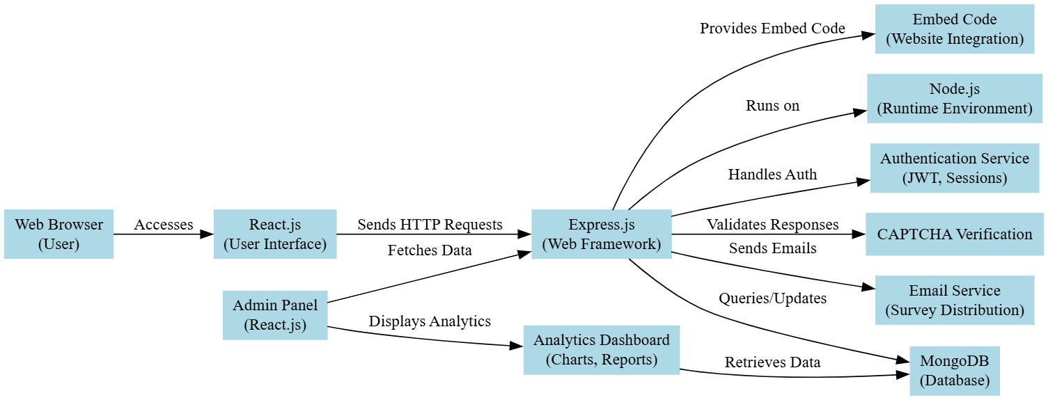

**Table-1: Components & Technologies for SurveyAppMERN**

| **S.No** | **Component** | **Description** | **Technology Stack** |
| --- | --- | --- | --- |
| 1 | **User Interface** | Web and mobile-responsive survey interfaces | React.js, Redux Toolkit, Tailwind CSS |
| 2 | **Application Logic-1** | User authentication & role management | Node.js (Express.js), JWT, OAuth 2.0 |
| 3 | **Application Logic-2** | Survey creation & response collection | Node.js, Socket.io (real-time updates) |
| 4 | **Application Logic-3** | Payment processing & subscription logic | Stripe API, Razorpay API |
| 5 | **Database** | User data, surveys, and responses storage | MongoDB Atlas (NoSQL) |
| 6 | **Cloud Storage** | File uploads (images/docs for surveys) | AWS S3 / Firebase Storage |
| 7 | **External API-1** | Analytics integration (charts/dashboards) | Chart.js, D3.js |
| 8 | **External API-2** | Social media sharing (survey distribution) | Facebook API, LinkedIn API |
| 9 | **Recommendation Engine** | AI-driven survey question suggestions | Python (NLTK/TensorFlow.js) |
| 10 | **Infrastructure** | Deployment & orchestration | AWS EC2, Docker, Kubernetes (EKS) |

**Table-2: Application Characteristics for SurveyAppMERN**

| **S.No** | **Characteristics** | **Description** | **Technology Stack** |
| --- | --- | --- | --- |
| 1 | **Open-Source Frameworks** | Core frameworks used for development | React.js, Express.js, Mongoose |
| 2 | **Security Implementations** | End-to-end data protection and compliance | JWT, OAuth 2.0 (Google/Facebook), HTTPS/TLS, Helmet.js, rate-limiting |
| 3 | **Scalable Architecture** | Modular design with horizontal scaling capabilities | AWS ECS, MongoDB Atlas (Sharded Clusters), Load Balancers |
| 4 | **Availability** | Multi-AZ deployment with failover mechanisms | AWS Multi-Region Deployment, MongoDB Atlas Global Clusters |
| 5 | **Performance** | Optimized for high-concurrency response submissions and real-time analytics | Redis Caching, CDN for static assets, MongoDB Aggregation Pipeline optimizations |
| 6 | **Accessibility** | WCAG 2.1 AA compliant interfaces | ARIA tags, Keyboard navigation, High-Contrast Themes |
| 7 | **Data Integrity** | Backup and recovery solutions | AWS S3 Backups, Point-in-Time Recovery (MongoDB Atlas) |